**Reg. No. 21BCE1297 Name: Vidhi Shah Date of Practical: 28/05/22**

**Experiment 10**

**Aim:**

Draw I-V characteristics graph for PN Junction diode and Zener Diode

**Tools and Apparatus:**

­LTSpice, PN junction diode, Zener diode, Resistor, Voltmeter, Ammeter, Voltage Source

**Theory and Design:**

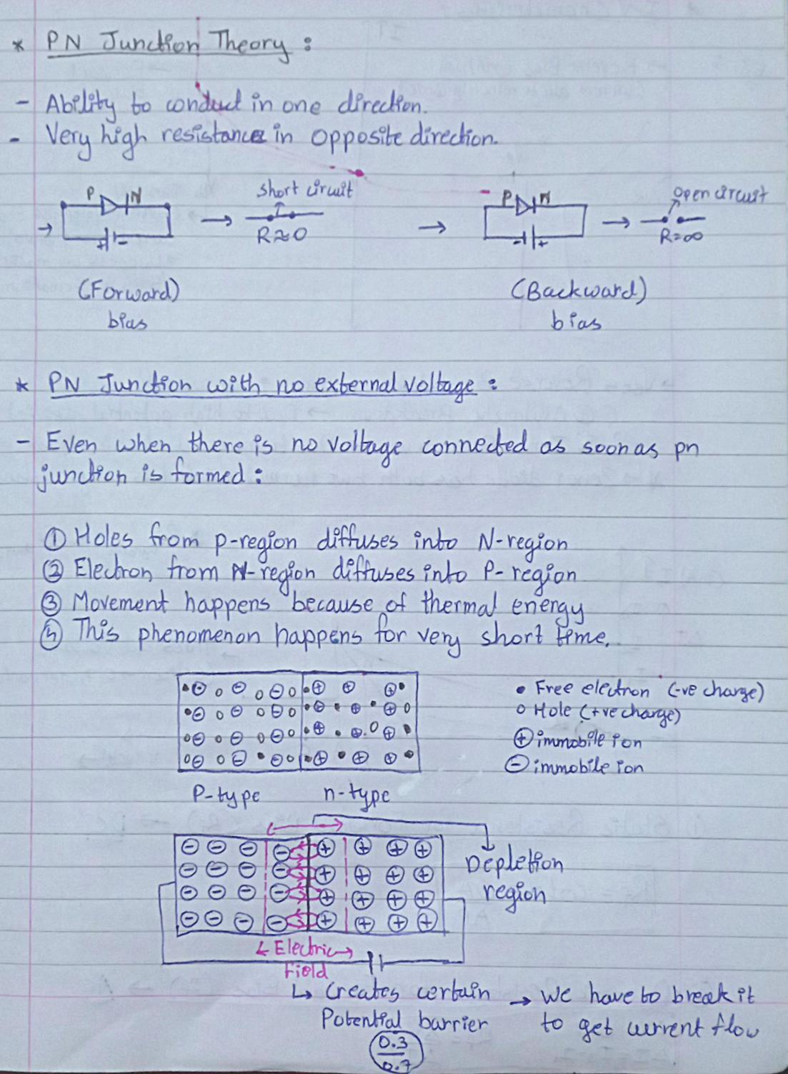

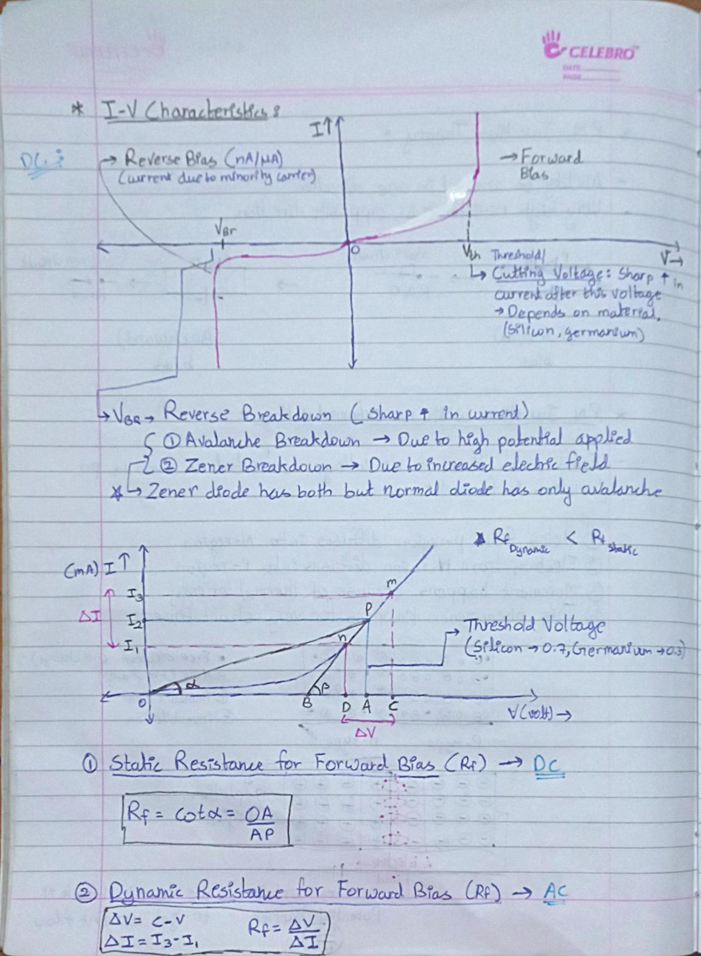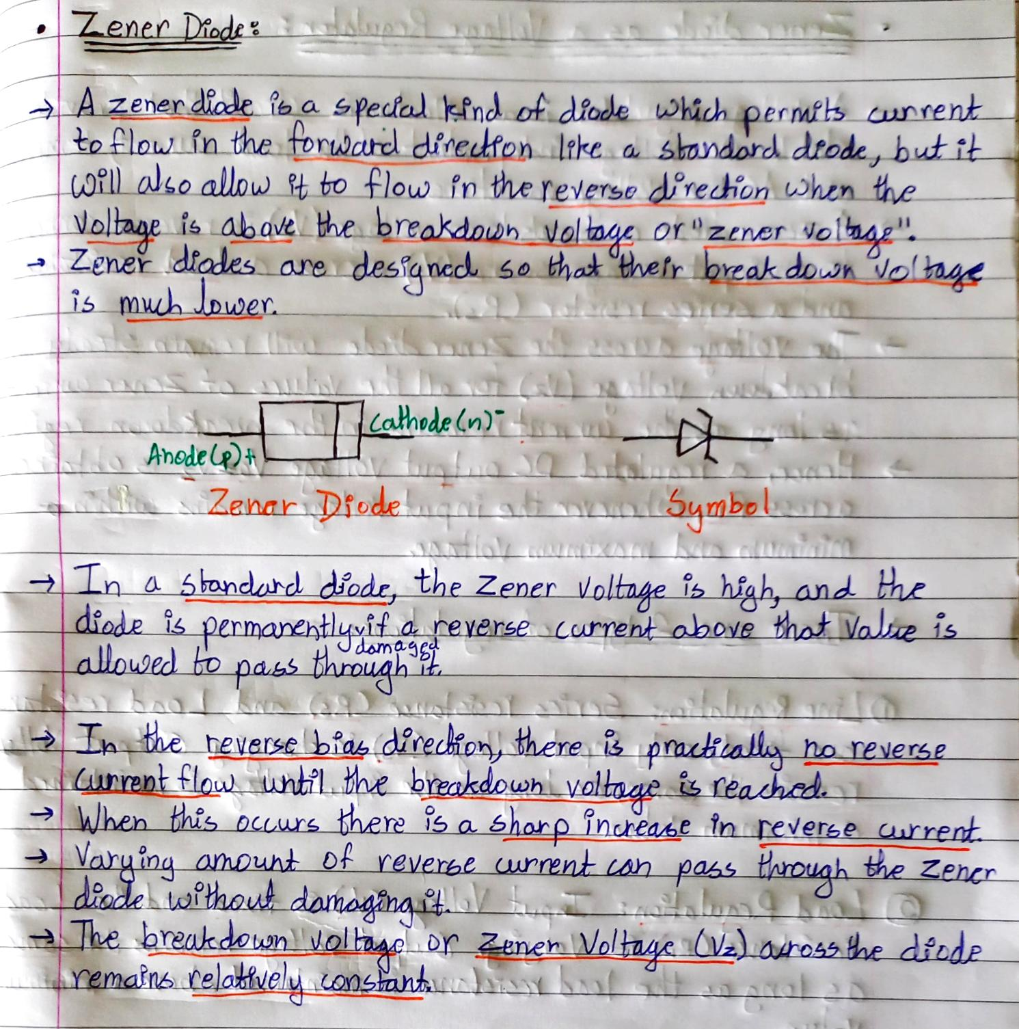

**Hardware Simulation Results:**

1) PN Junction

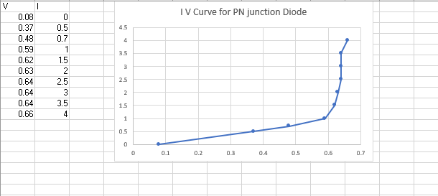

2) Zener Diode

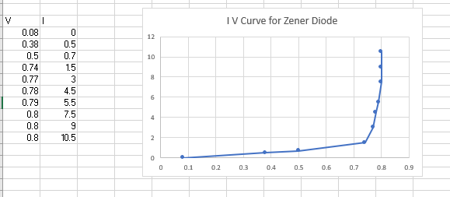

Circuit Diagram:

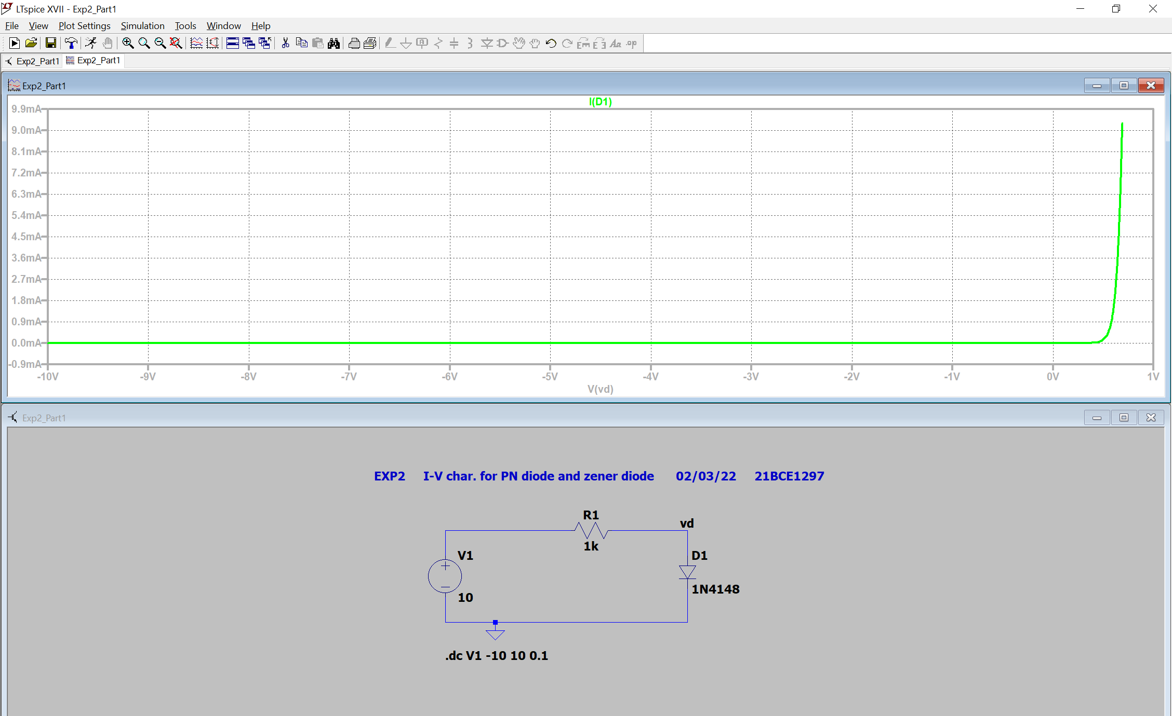

**Software Simulation Results:**

****1) Forward Bias

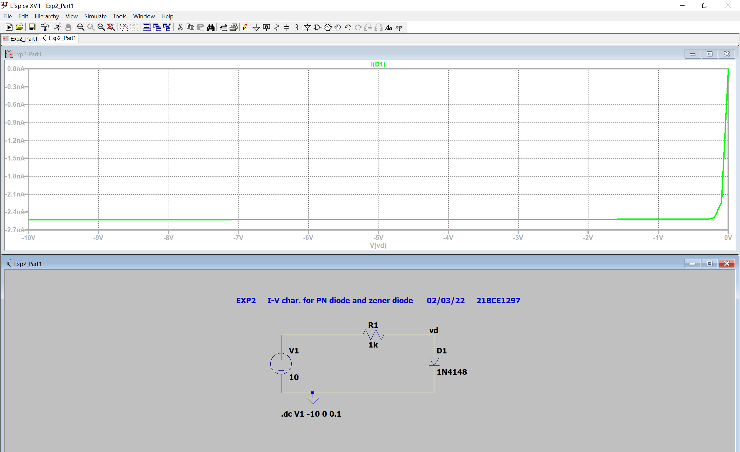2) Reverse Bias

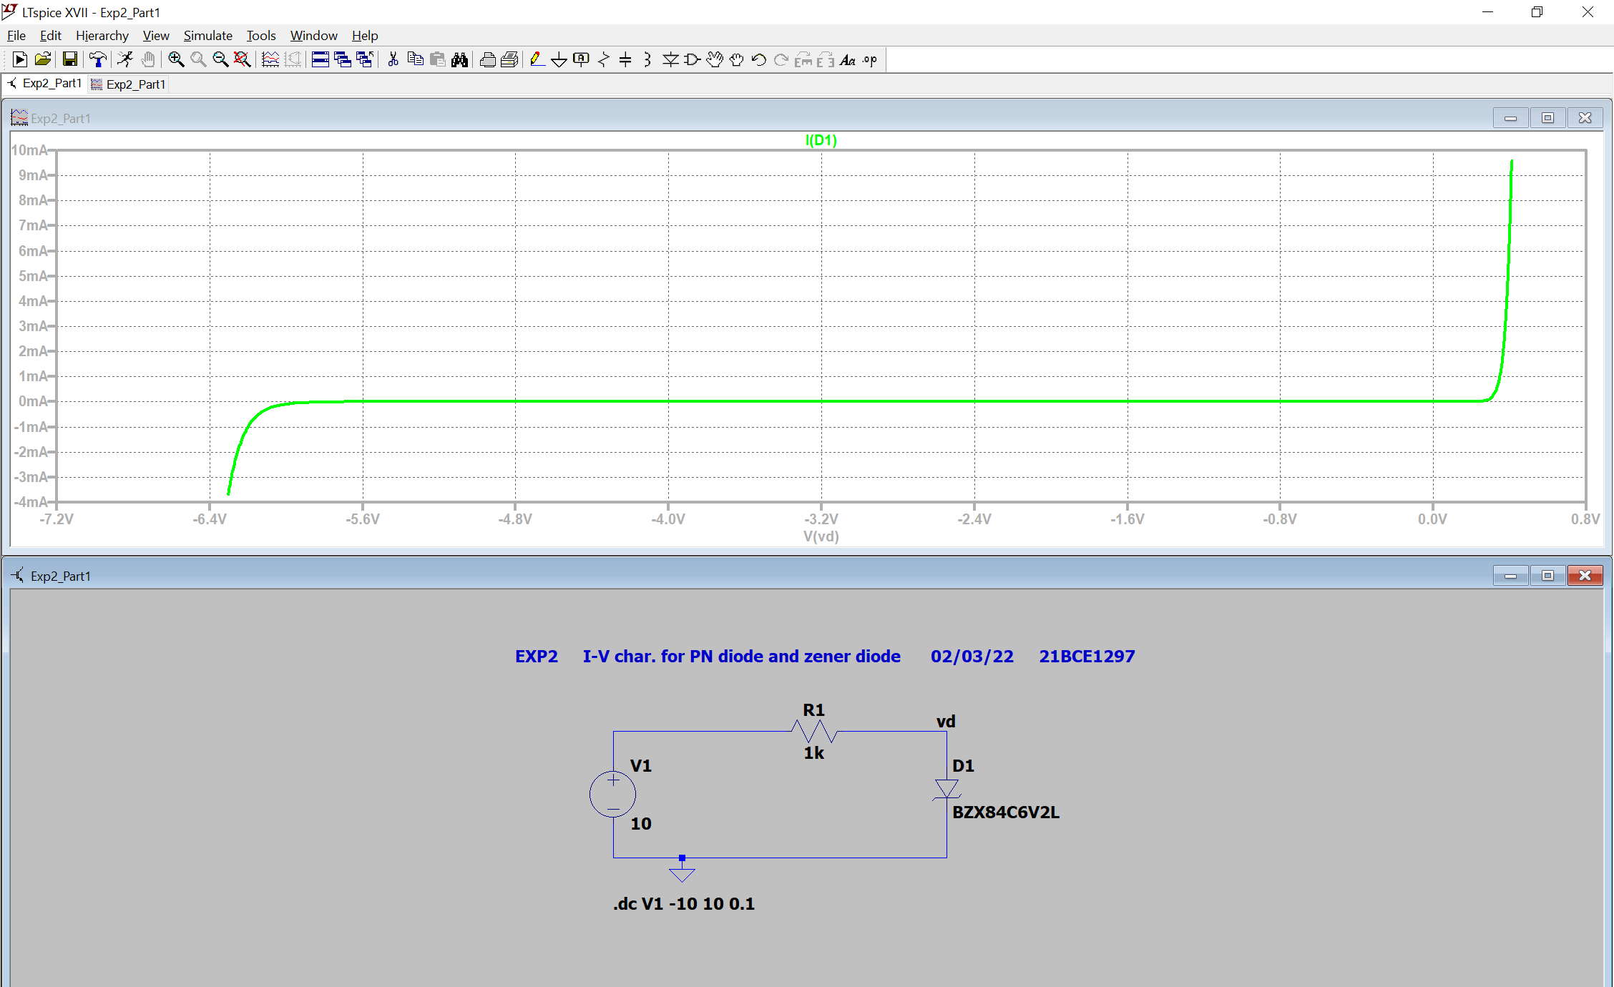3) Zener Diode

**Conclusion:**

I-V Characteristics curve of PN Junction diode and Zener diode is verified.

**Inferences:**

1. Threshold voltage and breakdown voltage for Zener diode and PN junction diode is clearly visible.
2. Connect all wires properly and tightly.
3. Label vd properly